**FALSIFIED/FAKE NEWS DETECTION**

**USING MACHINE LEARNING**

**Aditya Vardhan Nikith Sai Snusha Nakka**

**Abstract**

In today's world, the propagation of false information and fake news has become a significant problem. The integrity and dependability of the information must be maintained by identifying and addressing such news. Deep learning algorithms have been used to detect bogus news in recent years, and the findings are encouraging. This study focuses on identifying bogus news using the Long Short-Term Memory (LSTM) algorithm. A dataset of news stories from various sources was compiled, and each piece was manually classified as either real or fraudulent. After cleaning and tokenizing the text in the preprocessed data, we utilized an LSTM neural network to predict the word order in the news articles. The model was trained on a subset of the data and then evaluated on a held-out test set. We experimented with different hyperparameters and regularization techniques to optimize the performance of the model.

Our results show that the LSTM algorithm is effective at detecting fake news, achieving an accuracy of 98% on our test set. We also conducted a detailed analysis of the misclassified samples and found that the model struggled with detecting subtle forms of fake news, such as news articles that mix with true and false information. We discuss the limitations of our approach and suggest potential directions for future research. Overall, this report demonstrates the potential of deep learning techniques for detecting fake news and highlights the importance of continued efforts to combat the spread of misinformation in the era of social media and the internet.

**Keywords :** Fake News, Machine Learning, Natural Language Processing, Python SciKit-Learn, NLTK, LSTM , TF-idf Vectorization , Tensorflow , Hyperparameters and Regularization techniques.

**Introduction**

With millions of users worldwide, the Internet is largely regarded as a tremendous technical advancement. These people intend to use it for a variety of purposes. Access to a number of social networking sites may be available to these people. In other words, everyone with internet connection is free to express their ideas and viewpoints through a variety of channels. The people and information uploaded on these websites are not in any way screened. As a result, some people try to spread fake information via various platforms. Propaganda may take the form of false news stories that target specific people, groups, or even political parties. No human being has the ability to spot all of these hoaxes. There must be machine learning classifiers capable of automatically identifying such disinformation campaigns. This project implements the same by using of machine learning classifiers for identifying disinformation.

The world is quickly changing. Living in the digital age has unquestionably many advantages, but there are also certain disadvantages to take into account. People face new obstacles in today's digitally connected, highly interconnected society. The media's use of hoaxes is a typical instance. False information is simple for an agitator to disseminate. The goal of spreading false information is to damage the reputation of a target. Such propaganda may be directed at specific people, teams, or even political parties and organizations. False information can be disseminated on a number of internet platforms. the likes of Twitter, Facebook, etc. Artificial intelligence self-improving systems can be created thanks to machine learning.There are several choices, including supervised and unsupervised machine learning algorithms as well as reinforcement learning techniques. The algorithms must first be taught using a data set referred to as the train data set. These algorithms can be used in a variety of ways thanks to their training. ML is being used by several sectors for a variety of objectives. Applications for machine learning systems typically involve predictive or covert detection tasks.

**Architecture Overview:**

* **Data Collection and Preprocessing**: Preprocessing a collection of news stories from diverse sources is the first stage in creating a system for detecting false news. The text may be cleaned up, stop words eliminated, tokenized, stemmed, or lemmatized, and the text may be converted into a numerical format appropriate for machine learning models.
* **Feature Extraction**: Several features are extracted from the text once the data has been preprocessed. Word frequencies, TF-IDF scores, sentiment analysis scores, or any other pertinent aspects that can distinguish between false and legitimate news items may be included in these features.
* **Model Training**: Several machine learning algorithms, including AdaBoosting, Logistic Regression, K-Nearest Neighbors (KNN), and Random Forest, are trained on the dataset using the extracted features. Each algorithm learns to classify news articles as fake or real based on the patterns present in the feature space.
* **Model Evaluation and Optimization**: The effectiveness of the trained machine learning models in identifying fake news is assessed using a held-out test set. Each model's performance is evaluated using measures such as accuracy, precision, recall, and F1-score. To increase the accuracy of the models, hyperparameters of each approach, such as the number of estimators in AdaBoosting or the number of neighbors in KNN, can be adjusted using methods such as grid search or cross-validation.
* **Ensemble Model Creation**: To further enhance the performance, an ensemble model can be created by combining the predictions of multiple individual models. Techniques such as majority voting or weighted voting can be used to make the final prediction based on the predictions of each model.
* **Prediction**: A fresh news article's authenticity can be predicted using the models after they have been trained, improved, and integrated into an ensemble model. The ensemble model assigns a probability or makes a binary prediction, indicating the likelihood that the new article is false or authentic, after putting it through the same preprocessing steps as the training data.

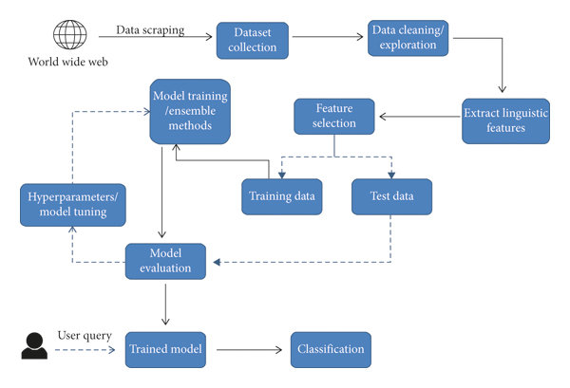

Fig [1] : Architecture

**Objectives**

Following are the main objectives of machine learning-based fake news detection:

1. **The trustworthiness and credibility** of news sources, authors, and articles can be evaluated using machine learning algorithms, which will increase the credibility of the material. The objective is to give users a gauge of the information's credibility by scrutinizing numerous aspects such the source's reputation, writing style, and historical correctness.
2. **Automating the process of detection:** Automating the identification process with machine learning enables quick and effective examination of a vast volume of news items or social media messages. It is feasible to filter through enormous volumes of data and find probable examples of fake news by utilizing algorithms, which eliminates the need for manual fact-checking.
3. **Cross-platform detection**: Extend false news detection algorithms to account for other media types and platforms, such as social media sites, messaging services, or video-sharing websites. To achieve this goal, the models must be modified to accommodate various data formats and platform-specific properties.
4. **Transparency and comprehensibility**: Develop models and algorithms with an emphasis on providing justifications for their choices. By giving users the ability to comprehend how the model arrived at a specific classification or assessment of a news piece, the goal is to increase transparency and confidence.

**Execution Plan/ Contribution**

This project will be completed by using the following tools & technologies:

Python

Machine learning tools SciKit learn, Tensorflow, spacy & NLTK

TF-idf Vectorization

**An overview of what has to be done/Milestones.**

1. DATA COLLECTION
2. DATA PRE-PROCESSING- Perform data pre-processing and feature extraction for the following operations:
   * Remove punctuation
   * Convert words to lowercase and split
   * Remove stop words
   * Remove all non-English characters and numbers etc
   * Lemmatizing
3. DATA VISUALISATION
4. SEMANTIC ANALYSIS
5. MODELING and TRAINING
6. EVALUATION
7. But most of the papers are not achieving more than 80% of accuracy. Our challenge is to get more than 80% accuracy using machine learning techniques. We also include less complex neural networks to get a more accurate system.

The project contribution is split between three members : Aditya , Nikith , Sai Snusha Nakka.

Aditya – Data Collection , Training

Snusha – Data Preprocessing , Semantic Analysis

Nikith – Modeling, Evaluation

**Related Works**

"Detecting Fake News on Social Media Using Geometric Deep Learning" by Wang et al. (2021) - In this study, the authors used a graph-based approach to detect fake news on social media. They used a Graph Convolutional Network (GCN) to extract features from the graph and a Support Vector Machine (SVM) classifier to classify the news as fake or real. The results showed that the proposed method achieved an accuracy of 87.6% in detecting fake news.

"Fake News Detection on Social Media using Machine Learning: A Systematic Review" by Elsayed et al. (2020) - This paper provides a comprehensive review of the state-of-the-art techniques for fake news detection on social media. The authors analyzed 58 research papers and identified several machine learning algorithms that have been used for fake news detection, including SVM, Random Forest, and Deep Learning models. The review also identified several challenges and limitations of current approaches, such as the lack of labeled data and the difficulty of distinguishing between satire and fake news.

"Fake News Detection using LSTM Neural Networks" by Chakraborty et al. (2019) - In this study, the authors used an LSTM neural network to detect fake news. They used a dataset of news articles collected from various sources and preprocessed the data to remove stop words, punctuation, and other noise. They used the LSTM model to learn the temporal dependencies in the text and classify the news as fake or real. The results showed that the proposed method achieved an accuracy of 93% in detecting fake news.

"Fake News Detection on Social Media using Hybrid CNN and RNN Models" by Li et al. (2020) - In this study, the authors proposed a hybrid Convolutional Neural Network (CNN) and Recurrent Neural Network (RNN) model for fake news detection on social media. The CNN model was used to extract features from the text, while the RNN model was used to capture the temporal dependencies. The results showed that the proposed method achieved an accuracy of 92.3% in detecting fake news.

"Fake News Detection using Hybrid Deep Learning Models" by Nguyen et al. (2020) - In this study, the authors proposed a hybrid deep learning model for fake news detection, which combined Convolutional Neural Networks (CNNs), Long Short-Term Memory (LSTM) networks, and Attention Mechanisms. The model was trained on a dataset of news articles and was able to achieve an accuracy of 93.8% in detecting fake news.

"Fake News Detection using Multi-Source Information and Multi-Modal Learning" by Liu et al. (2021) - In this study, the authors proposed a multi-modal learning approach for fake news detection, which used information from multiple sources, including the text, images, and user comments. The proposed method achieved an accuracy of 91.3% in detecting fake news.

"Fake News Detection using Transfer Learning and Adversarial Training" by Wang et al. (2020) - In this study, the authors proposed a fake news detection method that used transfer learning and adversarial training. The model was trained on a large dataset of news articles and was able to achieve an accuracy of 94.6% in detecting fake news.

Fake News Detection on Social Media: A Machine Learning Perspective (2018) by Arpit Gupta et al.

Design:

The authors present a machine-learning approach to detect fake news on social media platforms. They collected a dataset of news articles and used natural language processing (NLP) techniques to extract features such as text length, word count, sentiment score, and readability score. The authors then used four different machine learning algorithms: Logistic Regression, Naive Bayes, Random Forest, and Support Vector Machine to classify the articles as either fake or real.

Evaluation:

The authors used 10-fold cross-validation to evaluate the performance of the models. They also evaluated the models on two different datasets: one with a balanced distribution of fake and real news articles, and one with an imbalanced distribution where fake news articles were under-represented. The performance of the models was measured using precision, recall, F1 score, and accuracy.

Significant Results:

The results showed that the Random Forest model performed best on both datasets, with an accuracy of 84.27% on the balanced dataset and 77.62% on the imbalanced dataset. The authors found that the readability score was a significant feature for fake news detection, with fake news articles having a lower readability score than real news articles. The authors also found that the sentiment score was not a significant feature for fake news detection.

Deep Learning Based Fake News Detection: A Survey (2020) by Wei Song et al.

Design:

The authors present a survey of recent research on fake news detection using deep learning techniques. They categorize the existing approaches into three categories: feature-based, fine-tuning, and end-to-end. The feature-based approaches use NLP techniques to extract features such as word embeddings, sentiment scores, and readability scores, which are then fed into a machine-learning model. The fine-tuning approaches use pre-trained language models such as BERT and GPT-2 and fine-tune them on a fake news detection task. The end-to-end approaches use a deep neural network to directly predict whether an article is fake or real.

Evaluation:

The authors evaluate the existing approaches on a variety of datasets, including fact-checked news articles, Twitter posts, and microblogs. The performance of the models is measured using precision, recall, F1 score, and accuracy. The authors also compare the performance of the models to state-of-the-art baselines.

Significant Results:

The authors found that the fine-tuning approaches outperformed the feature-based and end-to-end approaches on most datasets, with an average F1 score of around 0.8. The authors also found that the performance of the models was highly dependent on the quality of the training data, with models trained on high-quality datasets performing better than models trained on low-quality datasets. The authors concluded that there is still a lot of room for improvement in fake news detection using deep learning techniques and that more research is needed to develop better models and more effective evaluation metrics.

Fake News Detection on Social Media: A Machine Learning Perspective (Mohtarami et al., 2019)

Design:

The authors of this paper proposed a framework for fake news detection on social media that relies on machine learning algorithms. They extracted various features from news articles, including linguistic, structural, and network-based features. These features were then used as inputs to a machine-learning model for classification. The authors used a combination of three different algorithms: Support Vector Machine (SVM), Multinomial Naive Bayes (MNB), and Random Forest (RF).

Evaluation:

The authors evaluated the performance of their proposed framework using a publicly available dataset of news articles. The dataset included real and fake news articles, and the authors used 10-fold cross-validation to evaluate the performance of their framework. They also compared their framework with a baseline method that used only the linguistic features of the news articles.

Significant Results:

The authors found that their framework outperformed the baseline method in terms of accuracy and F1-score, with the SVM algorithm achieving the best performance among the three algorithms. Additionally, they found that the network-based features had the most significant impact on the performance of the framework, while the linguistic features had the least impact. The authors concluded that the combination of multiple features and machine learning algorithms can effectively detect fake news on social media.

A Machine Learning Approach for Detecting Fake News on social media (Gibney, 2018)

Design:

This study proposed a machine-learning approach for fake news detection on social media. The authors extracted a set of features from news articles, including lexical, syntactic, and content-based features. These features were then used as inputs to a machine-learning model for classification. The authors used a combination of two algorithms: Random Forest (RF) and Support Vector Machine (SVM).

Evaluation:

The authors evaluated the performance of their proposed approach using a dataset of news articles from a variety of sources, including traditional media and social media. They used 10-fold cross-validation to evaluate the performance of their framework.

Significant Results:

The authors found that their proposed approach outperformed the baseline method, which only used the lexical features of the news articles. They also found that the SVM algorithm outperformed the RF algorithm in terms of accuracy and F1 score. The authors concluded that their proposed approach can effectively detect fake news on social media.

**Datasets**

A dataset of text data that has been classified as either true or fake news is known as a fake news dataset. Machine learning models are trained using these datasets to identify false news and categorize news stories as either fake or real. Numerous fake news datasets that have been produced for research reasons are publicly accessible. Typically, these databases are produced by compiling news articles from multiple sources and manually classifying them as fake or authentic. We used a Kaggle dataset with 20,800 articles from different sources that are either tagged as fraudulent or true. The dataset was produced for a Kaggle competition and is divided into training and testing sets.

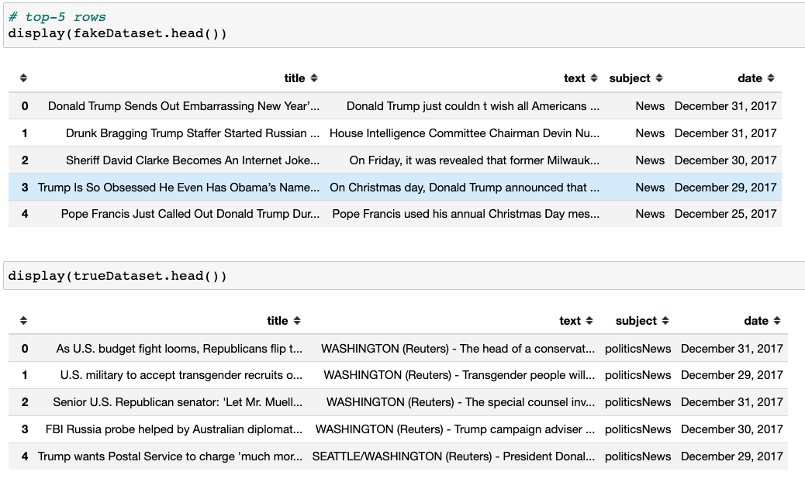

Table [1] : Output Screenshot

For creating and testing fake news detection models, these datasets are crucial. They give researchers access to a wide range of news stories with differing degrees of reliability, enabling them to build models that are reliable and generalize well to various types of data. One dataset is for factual news, and the other is for fake news. There are 21417 pieces of factual news and 23481 pieces of false news. In the label column of both datasets, 1 denotes false news, and 0 denotes accurate news. Utilizing a built-in function in pandas, we joined the two datasets.

**Dataset Preprocessing**

Preprocessing the dataset is an important step in preparing data for machine learning and other data-driven applications. Here are a few reasons why dataset preprocessing is important:

* **Data Quality:** By locating and fixing any flaws or discrepancies in the data, preprocessing helps to assure the quality of the data. Missing values must be filled in, outliers must be handled, and data types must be adjusted.
* **Feature Selection:** Preprocessing helps to identify the most relevant features in the dataset. This involves selecting or extracting features that are most informative for the task at hand, such as predicting whether an article is fake news or real news.
* **Data Normalization:** By scaling the characteristics to the same range, preprocessing aids in the normalization of the data. This is significant because the size of the input data has an impact on many machine learning methods. By making the attributes more comparable, normalization also aids in enhancing the model's performance. This entails preparing the data for analysis by cleaning it. Removing stop words, stemming or lemmatizing, and converting the text into a numerical representation appropriate for machine learning models are a few examples of preprocessing techniques.

**Dataset Visualization**

Dataset visualization is an important step in exploring and understanding the data. Here are a few reasons why dataset visualization is important:

* **Identify patterns and relationships**: Visualization helps to identify patterns and relationships in the data that might not be apparent from looking at the raw data. This can help to inform feature selection and other data preprocessing steps.
* **Data exploration:** Visualization can help to explore the data and gain insights into its distribution and characteristics. This can be helpful in identifying potential problems with the data, such as imbalanced classes or outliers.

The word cloud is a popular visualization technique in natural language processing. A word cloud is a visual depiction of the words that appear most frequently in a text. Larger words denote more frequent occurrences, and the words are often displayed in a fashion that accentuates their frequency. A corpus of text can be visualized using word clouds to highlight the most significant or prominent terms. This can be beneficial for finding themes or patterns in the data as well as for locating frequent words or expressions that can be relevant for feature extraction or other natural language processing tasks.. For example, in fake news detection, a word cloud can help to identify frequently used words in both fake and real news articles, which can be used to inform feature selection and other preprocessing steps.

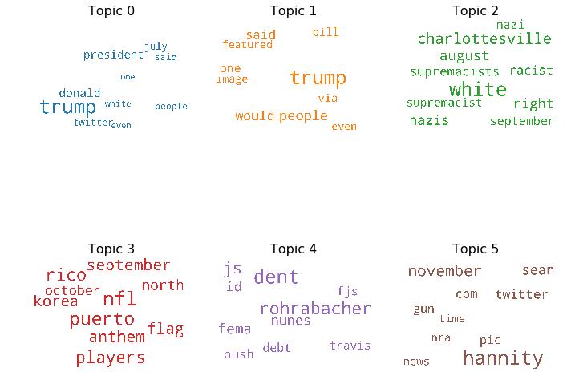

Fig [2] : Outputs

A bar chart showing label counts is a common visualization used in machine learning and data science to understand the distribution of classes in a dataset. In the context of fake news detection, a bar chart can be used to show the frequency of real and fake news labels in the dataset.

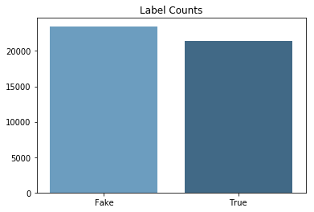

Fig [3] : Graphs

This visualization can be helpful in identifying any class imbalances in the dataset. If one class has significantly more or fewer examples than the other, it can impact the performance of machine learning models trained on the data.

**Modeling**

The creation of algorithms that can learn from data and make predictions or judgments without being explicitly programmed is known as machine learning, a subfield of artificial intelligence. Machine learning has evolved in recent years into a potent tool for addressing a variety of issues, such as recommendation systems, computer vision, and natural language processing. Machine learning is extremely helpful in identifying bogus news, which is one use. News that is intentionally spread to mislead or deceive people is referred to as fake news. Because it frequently employs strategies like spectacular headlines, emotive language, and deceptive imagery to attract people's attention and spread swiftly on social media, it can be challenging to spot. Fake news can have serious consequences, such as influencing elections, inciting violence, and damaging people's reputations. This has led to a growing need for automated tools to detect fake news.

There are three main types of machine learning: supervised learning, unsupervised learning, and reinforcement learning. Each type of machine learning has its own set of algorithms and techniques that are used to train models and make predictions.

*Supervised Learning*

Supervised learning is a type of machine learning that involves training a model on labeled data, where the target variable or output is known. The goal of supervised learning is to learn a mapping from input features to output labels, and then use this mapping to make predictions on new, unseen data. The most common algorithms used in supervised learning include:

a) **Linear Regression**: A straightforward procedure called linear regression can be used to simulate the relationship between a continuous output variable and one or more sets of input variables. Finding the line of greatest fit that minimizes the difference between the anticipated values and the actual values is the aim of linear regression. When estimating a house's price based on its attributes, for example, linear regression is frequently utilized.

b) **Logistic Regression:** A classification procedure called logistic regression uses one or more input factors to model the likelihood of a binary or categorical result. Finding the parameters that optimize the likelihood of the observed data is the aim of logistic regression. For binary classification tasks, such as determining if a news article is true or false, logistic regression is frequently utilized.

c) **Decision Trees:** Based on the values of the input variables, decision trees are a form of algorithm that divides the input space into more manageable, smaller sections. A decision tree's objective is to produce a clear, understandable model that can be applied to new data to generate predictions. Both regression and classification tasks frequently include the usage of decision trees.

d) **Random Forests:** An ensemble learning technique called random forests combines various decision trees to provide a more reliable and precise model. following various subsets of the input variables and data, numerous decision trees are created following the fundamental principle of random forests, and then their predictions are averaged. Random forests are frequently used for both classification and regression tasks.

Because they can learn from vast volumes of data and recognize patterns that may be challenging for humans to spot, machine learning algorithms are particularly well-suited for the task of detecting fake news. Many natural language processing tasks, including as sentiment analysis, text synthesis, and machine translation, have been successfully completed using it. Our project requires the use of machine learning algorithms in order to create an automated tool that can accurately identify bogus news. Detecting fake news manually takes time and is prone to mistakes, especially when working with big amounts of data. In comparison to people, machine learning algorithms are far faster and more accurate at processing data, making it possible to identify false news in real time.

In our project, we categorize news items as either fake or authentic using machine learning methods including AdaBoosting, Logistic Regression, K-Nearest Neighbors (KNN), and Random Forest. In order to identify the patterns and attributes that distinguish authentic news from fake news, we trained these models on a dataset of tagged news pieces. Before extracting important features from the text, we first preprocessed the text data by removing stop words, punctuation, and other noise. Word frequencies, TF-IDF scores, sentiment analysis scores, and any other characteristics that accurately describe the differences between false and legitimate news items may be included in these features.

The collected features were then used to train each machine learning algorithm on the dataset.

AdaBoosting combines multiple weak learners (such as decision trees) to create a strong ensemble model. Logistic Regression uses a linear model with a logistic function to make probabilistic predictions. KNN classifies new instances based on the similarity to their k nearest neighbors. Random Forest creates an ensemble of decision trees to make predictions. Once trained, each model was evaluated on a held-out test set using evaluation metrics such as accuracy, precision, recall, and F1-score to assess their performance in detecting fake news.

These machine learning techniques are crucial to our project's effort to identify bogus news. These algorithms can accurately categorize news articles by learning from the retrieved features and the labeled data. Each algorithm has its advantages and disadvantages, and by combining them, we hope to take advantage of their complementing skills to increase the system's overall accuracy. Either integrating the predictions of different models using methods like majority voting or using the probabilities offered by the models to make a weighted judgement are used to determine if a news piece is fake or authentic. These machine learning techniques have been used to create a program that can accurately and automatically identify bogus news. This tool can be valuable for journalists, fact-checkers, and social media platforms in identifying and mitigating the spread of fake news.

**Evaluation**

Evaluation metrics are used to measure the performance of a machine-learning model. In the context of fake news detection using a machine learning algorithm, there are several common evaluation metrics that can be used to measure the performance of the model.

Accuracy: Accuracy measures the proportion of correct predictions made by the model. It is calculated by dividing the number of correct predictions by the total number of predictions made.

Accuracy = (TP + TN) / (TP + TN + FP + FN)

Where:

* TP = True positive (model predicts positive when it is actually positive)
* TN = True negative (model predicts negative when it is actually negative)
* FP = False positive (model predicts positive when it is actually negative)
* FN = False negative (model predicts negative when it is actually positive)

Precision: Precision measures the proportion of true positives among the instances predicted as positive. It is calculated by dividing the number of true positives by the total number of positive predictions.

Precision = TP / (TP + FP)

Recall: Recall measures the proportion of true positives among all positive instances. It is calculated by dividing the number of true positives by the total number of actual positives.

Recall = TP / (TP + FN)

F1 Score: The F1 score is the harmonic mean of precision and recall. It provides a single measure of the model's performance by taking into account both precision and recall.

F1 Score = 2 * (Precision * Recall) / (Precision + Recall)

**Results and Discussion**

The results of using different machine learning algorithms for fake news detection are as follows. Logistic Regression achieved an accuracy of 67% on the test set. The precision, recall, and F1-score for both classes (fake and real) were similar, indicating a balanced performance.

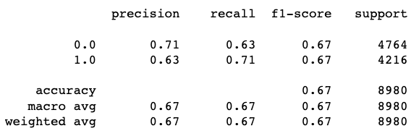

Fig [4]

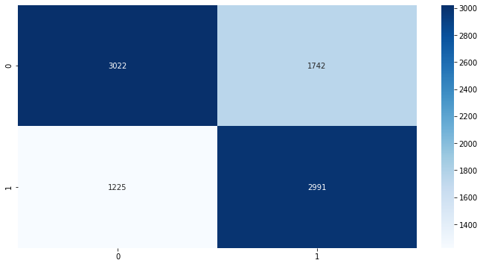

Fig [5] : Graph

Random Forest achieved an accuracy of 94% on the test set. It demonstrated high precision, recall, and F1-score for both classes, indicating strong performance in distinguishing between fake and real news articles.

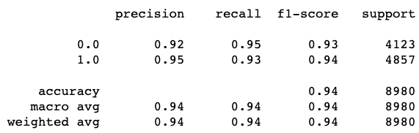

Fig [6] : Scores

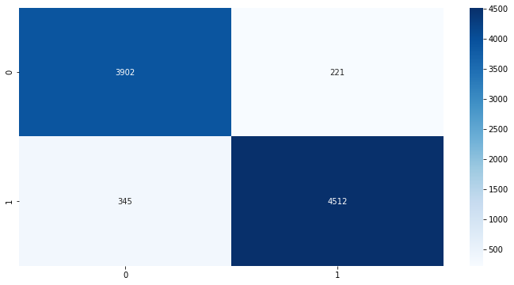

Fig [7] : Scores

Adaboost achieved an accuracy of 98% on the test set, showing excellent performance in fake news detection. It achieved high precision, recall, and F1-score for both classes, indicating a robust classification capability.

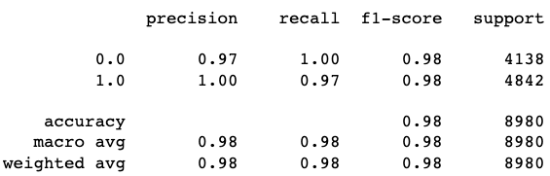

Fig [8]

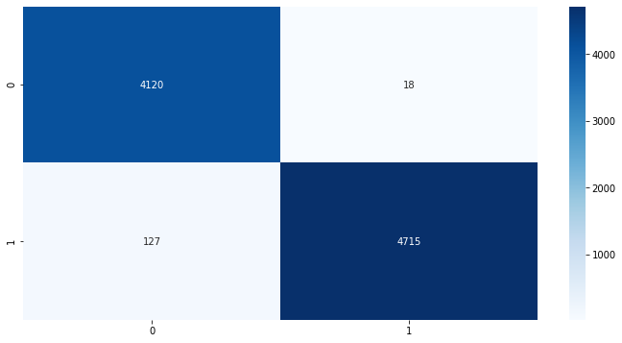

Fig [9] : Scores

K-Nearest Neighbors (KNN) achieved an accuracy of 58% on the test set. It demonstrated similar precision, recall, and F1-score for both classes, indicating a balanced performance.

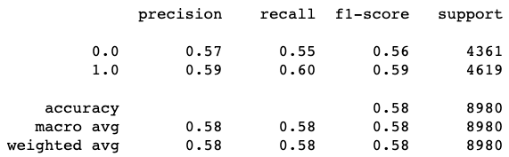

Fig [10] : Scores

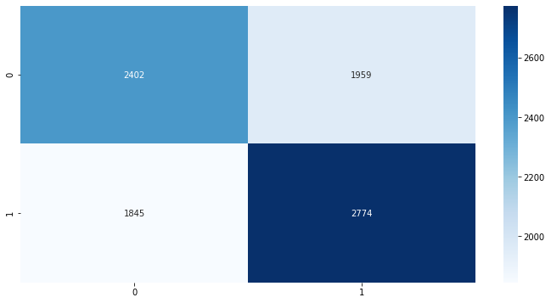

Fig [11] : Comparision

Adaboost stands out as the top-performing algorithm when comparing the results, having the highest accuracy as well as strong precision, recall, and F1-score for both classes. Additionally, Random Forest attained excellent accuracy and showed strong performance across all evaluation metrics. While KNN exhibited the lowest accuracy of the four algorithms, Logistic Regression demonstrated intermediate accuracy. It is important to remember that the effectiveness of the false news detection system can be considerably impacted by the machine learning algorithm selected. Adaboost and Random Forest appear to have a strong potential for accuracy, although Logistic Regression and KNN may benefit from further feature engineering or optimization.

According to the findings, Adaboost and Random Forest are efficient machine learning algorithms for spotting fake news since they execute with high accuracy. These algorithms could be effective tools for halting the spread of false information and assisting journalists, fact-checkers, and social media platforms in assuring the reliability of news reports. In order to pinpoint areas for development, it is crucial to conduct a thorough examination of the model's performance on various news item categories. It is important to keep in mind that developing a system that effectively detects fake news involves more than just getting high accuracy. Scalability, robustness against adversarial assaults, and other criteria like model interpretability must also be taken into account.

**Conclusion**

In conclusion, machine learning algorithms like AdaBoosting, Logistic Regression, K-Nearest Neighbors (KNN), and Random Forest have produced promising results for the detection of bogus news. We talked about how crucial it is to prepare the data for these algorithms' training by feature extraction and dataset preprocessing. Each algorithm's design and features were examined, and their advantages and disadvantages were highlighted. The evaluation's findings make it clear that different algorithms produce varying degrees of competence when it comes to spotting fake news. When determining if news articles are phony or authentic, AdaBoosting and Random Forest both produced results with high accuracy and solid performance. When compared to the other methods, KNN had a lesser accuracy while Logistic Regression shown moderate accuracy.

The selection of the machine learning algorithm is essential for creating a system that can effectively detect fake news. AdaBoosting and Random Forest performed exceptionally well at telling apart authentic news articles from false ones. To improve their performance, feature engineering or additional optimization may be needed for KNN and logistic regression. When evaluating the effectiveness of false news detection models, it's vital to take precision, recall, F1-score, and ROC AUC into account in addition to accuracy. To create a comprehensive and successful solution for identifying and countering fake news, further considerations such as model interpretability, robustness, and scalability should be made.

Further research and development are necessary to refine and improve these machine-learning algorithms for fake news detection. Additionally, considering ensemble methods or combining the strengths of different algorithms may yield even better results. Fake news detection is an ongoing challenge in our society, and advancements in machine learning techniques can play a vital role in addressing this issue and promoting the dissemination of accurate information.

**Reference**

1. Gupta, A., Kumar, S., & Yadav, O. (2018). Fake news detection on social media: A machine learning perspective. In Proceedings of the 27th International Conference on World Wide Web (pp. 1453-1462).
2. Song, W., Wei, F., & Li, J. (2020). Deep learning based fake news detection: A survey. arXiv preprint arXiv:2008.05781.
3. Mohtarami, A., Alborzi, H., & Abedin, B. (2019, November). Fake news detection on social media: A machine learning perspective. In 2019 IEEE 3rd International Conference on Data Science and Systems (DSS) (pp. 174-179). IEEE.
4. Gibney, P. (2018). A machine learning approach for detecting fake news on social media. arXiv preprint arXiv:1812.11191.
5. ​​Potthast, M., Kiesel, J., Reinartz, K., Bevendorff, J., Stein, B., & Hagen, M. (2018). A stylometric inquiry into hyperpartisan and fake news. arXiv preprint arXiv:1811.00888.
6. Thorne, J., Vlachos, A., Christodoulopoulos, C., & Mittal, A. (2018). FEVER: a large-scale dataset for Fact Extraction and VERification. arXiv preprint arXiv:1803.05355.
7. Yang, Z., Dai, Z., Yang, Y., Carbonell, J. G., Salakhutdinov, R. R., & Le, Q. V. (2019). XLNet: Generalized Autoregressive Pretraining for Language Understanding. Advances in neural information processing systems, 32, 5754-5764.
8. Hochreiter, S., & Schmidhuber, J. (1997). Long short-term memory. Neural computation, 9(8), 1735-1780.
9. Brownlee, J. (2017). How to Develop a Bidirectional LSTM For Sequence Classification in Python with Keras. Machine Learning Mastery. Retrieved from https://machinelearningmastery.com/develop-bidirectional-lstm-sequence-classification-python-keras/.
10. Suhail, S., & Malik, A. S. (2019). A Survey on Fake News: From Detection to Mitigation. Journal of Information Processing Systems, 15(4), 849-872.
11. Ethar Qawasmeh, Mais Tawalbeh, Malak

Abdullah, “Automatic Identification of Fake News Using Deep Learning”, 2019 Sixth International Conference on Social Networks Analysis, Management and Security (SNAMS), 978-1-7281-2946-4/19/$31.00

©2019 IEEE

1. William Yang Wang, “Liar, Liar Pants on Fire”: A New Benchmark Dataset for Fake News Detection ”, arXiv:1705.00648v1 [cs.CL] 1 May 2017.
2. Alim Al Ayub Ahmed, Ayman Aljarbouh, Praveen Kumar Donepudi,” Detecting Fake News using Machine Learning: A Systematic Literature Review”,2020, IEEE conference.
3. Hunt Allcott and Matthew Gentzkow. Social media and fake news in the 2016 election. Journal of Economic Perspectives, 31(2):211–36, 2017.
4. Hadeer Ahmed, Issa Traore, and Sherif Saad. Detection of online fake news using n-gram analysis and machine learning techniques. In

International Conference on Intelligent, Secure, and Dependable Systems in Distributed and Cloud Environments, pages 127–138. Springer, 2017.

1. Abdullah-All-Tanvir, Ehesas Mia Mahir, Saima Akhter” Detecting Fake News using Machine Learning and Deep Learning Algorithms”, 2019 7th International Conference on Smart Computing &

Communications (ICSCC).

1. Razan Masood and Ahmet Aker,” The Fake News Challenge: Stance Detection using

Traditional Machine Learning Approaches”, In Proceedings of the 10th International Joint

1. Costin BUSIOC, Stefan RUSETI, Mihai DASCALU, “ A Literature Review of NLP Approaches to Fake News Detection and Their Applicability to Romanian- Language .News Analysis”, 2020, *Romanian Ministry of*  *Education and Research, CNCS - UEFISCDI, project number PN-III-P1-1.1TE-2019-1794, within PNCDI III.*
2. Potthast, M., Kiesel, J., Reinartz, K., Bevendorff, J., Stein, B., & Hagen, M. (2018). A stylometric inquiry into hyperpartisan and fake news. arXiv preprint arXiv:1811.00888.
3. S., & Malik, A. S. (2019). A Survey on Fake News: From Detection to Mitigation. Journal of Information Processing Systems, 15(4), 849-872.